Name: ______________________________________________________ Hour: _______ Date: ______________

Onion Articles Satire Analysis

*The Onion* is an American digital media company and news satire organization. It runs an entertainment website featuring satirical articles reporting on international, national, and local news.

**Directions:** please select 2 of the following items to read and analyze.

|  |  |  |
| --- | --- | --- |
|  | 1. **Name of article**   **__________________________** | 1. **Name of article**   **_____________________________** |
| **Object of Satire**  **Who is the target?** |  |  |
| **Why is it funny?**  **Tools used to create satire (DESCRIBE THEM)** |  |  |
| **What is the author saying about the subject?**  **(The implied message/criticism of society?)** |  |  |

Jogger Clearly On First Run of Plan to Turn Life Around

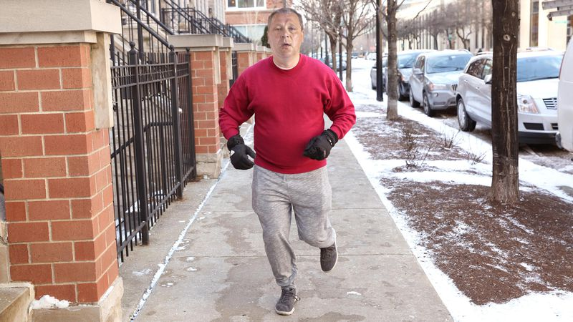

CHICAGO—Taking note of the man’s beat-up tennis shoes, sweat-drenched shirt, and ill-fitting pair of sweatpants as he made his way down the sidewalk, witnesses reported Tuesday that area jogger Dan Andreychuk was clearly out on his very first run of a plan to turn his life around. “He just started jogging, like, a block or two back, but he already looks really winded—this guy obviously just decided to get his life back on track within the past couple days,” said onlooker Paul Gerstein, surmising that the man had likely been inspired to choose a running distance far beyond his capabilities after recently taking stock of his limited career and relationship prospects, looking at himself in the mirror in disappointment, or watching a TED talk on how to become one’s best self. “Just look at how slow he’s going. This is almost certainly just a part of a whole self-improvement routine he’s putting together with push-ups and sit-ups and maybe some little dumbbell exercises, too.” Witnesses reported seeing a red-faced Andreychuk gasping for air with his hands on his knees several minutes later, clearly entertaining the very first doubts about his resolve that will soon derail his grand plan to remake himself.

Girl Move­ To Tears by Of Mice and Men Cliff Notes from ‑ the Onion

CHARLOTTESVILLE, VA—In what she described as “the most emotional moment” of her academic life, University of Virginia sophomore communications major Grace Weaver sobbed openly upon concluding Steinbeck’s seminal work of American ‑ fiction Of Mice And Men’s Cliff s Notes early last week.

“­this book has changed me in a way that only great literature summaries can,” said Weaver, who was so shaken by the experience that she requested an extension on her English 229 essay. ““The humanity displayed in the Character Flowchart really stirred something in me. And Lennie’s childlike innocence was beautifully captured through the simple, ranch-hand slang words like ‘mentally handicapped’ and ‘retarded.’”

Added Weaver: “I never wanted the synopsis to end.”

Weaver, who formed an “instant connection” with Lennie’s character-description paragraph, said she began to suspect the novel might end tragically after reading the fourth sentence which suggested the gentle giant’s strength and fascination with so things would “lead to his untimely demise.”

“I was amazed at how attached to him I had become just from the critical commentary,” said Weaver, still clutching the yellow-and-black-striped study guide. “When I got to the last sentence—‘George shoots Lennie in the head,’—it seemed so abrupt. But I found out later that the ‘ephemeral nature of life’ is a major theme of the novel.”

Weaver was assigned Of Mice And Men—a novel scholars have called “a masterpiece of austere prose” and “the most skillful example of American naturalism under 110 pages”—as part of her early twentieth-century ‑ fiction course, and purchased the Cliff s Notes from a cardboard rack at her local Barnes & Noble. John Whittier- Ferguson, her professor for the class, told reporters this was not the ‑first time one of his students has expressed interest in the novel’s plot summary.

“It’s one of those universal American stories,” said Ferguson after being informed of Weaver’s choice to read the Cliff s Notes instead of the pocket-sized novel. “I look forward to skimming her essay on the importance of following your dreams and randomly assigning it a grade.”

Though she completed the two-page brief synopsis in one sitting, Weaver said she felt strangely drawn into the plot overview and continued on, exploring the more fleshed-out chapter summaries.

“­ There’s something to be said for putting in that extra time with a good story,” Weaver said. “You just get more out of it. I’m also going to try to find that book about rabbits that George was always reading to Lennie, so that I can really understand that important allusion.”

Within an hour of completing the Cliffs Notes, Weaver was already telling friends and classmates that Steinbeck was her favorite author, as well as reciting select quotations from the “Important Quotations” section for their benefit.

“When I read those quotes, found out which characters they were attributed to, and inferred their context from the chapter outlines to piece together their significance, I was just blown away,” said a teary-eyed Weaver. “And the way Steinbeck wove the theme of hands all the way through the section entitled ‘Hands’—he definitely deserved to win that Nobel Prize.”

Weaver’s roommate, Giulia Crenshaw, has already borrowed the dog-eared, highlighted summary of the classic Depression-era saga, and is expecting to enjoy reading what Weaver described as “a really sad story about two brothers who love to farm.”

“I loved this book so much, I’m going to read all of Steinbeck’s Cliffs Notes,” said Weaver. “But first I’m going to go to the library to check out the original version Of­ Miceand Men starring John Malkovich and Gary Sinise.”

Industrial Revolution Provides Millions Of Out-Of-Work Children With Jobs

*The Onion.* [News](http://www.theonion.com/features/news/) • [year in review 2009](http://www.theonion.com/channels/year-in-review-2009/) • [business](http://www.theonion.com/channels/business/) • [ISSUE 45•51](http://www.theonion.com/issue/4551/) • Dec 14, 2009

After centuries of chronic unemployment, millions of small children across the United Kingdom saw their lives drastically improve when the Industrial Revolution at long last provided them with steady factory work regardless of age, size, or experience.

"Before the turn of the 19th century, frail boys and girls had no choice but to sit at home all day, playing with their younger siblings, just watching as another empty, unproductive week passed them by," noted British scholar William Donnelley said. "Once the Industrial Revolution began, however, any child able to fit inside a narrow mining shaft, or reach deep within a malfunctioning textile press, could venture out into the world and find himself a job."

Added Donnelley, "It was a time of unprecedented opportunity for the nation's 5- to 9-year-olds."

According to records, the introduction of machine-based manufacturing provided a desperately needed solution to England's toddler-unemployment epidemic. Out-of-work children, many of whom had struggled since birth to earn any kind of wage at all, were now afforded the chance to work seven days a week, up to 19 hours a day, in such competitive industries as iron-smelting and steel-tempering.

Not only was finding employment easier than ever for countless preadolescents, but the generous overtime available to them allowed boys and girls to catch up on years of experience they had lost while learning how to walk, nurse, or, in some unfortunate cases, attend several months of school.

"As a child of the time, it must have felt wonderful to be able to go to bed at night, confident in the knowledge that a job as a coal-boy, furnace operator, or even bore-grinder machinist awaited you the next morning," historian Russell Black said. "The sense of satisfaction and well-being all those orphans must have experienced week in and week out—it's hard to imagine."

"After all, there's nothing like a full-time job to help someone get back on his feet," Black continued. "Especially if he's lost one of them in a horrifying threshing accident." http://www.theonion.com/static/onion/img/terminator_1x.png

[**SPORTS NEWS IN BRIEF**](http://www.theonion.com/features/sports-news-in-brief) 2.4.15

**New England Fans: ‘We Don’t Deserve This’**



BOSTON—Having watched the Patriots win their fourth Super Bowl title in 14 years, sports fans across New England issued a thoughtful and introspective joint statement Wednesday announcing that they in no way deserve any of the success their teams have enjoyed over the past two decades. “When you stop and think about it, we’re loud-mouthed, we’re antagonistic, and we’re unbearably pompous, so there’s really no way we should have been able to enjoy four Super Bowls, three World Series, an NBA title, and a Stanley Cup since 2001,” read the statement in part, which added that “you can think of at least a dozen other fan bases off the top of your head” that would be far better served than Boston with teams that combined for nine different championships over the last 15 years. “The 2004 World Series was really the only thing that you could argue we had coming after waiting almost 100 years since our last one. But considering the way we angrily overreact to the slightest criticism of our teams—always brushing off even warranted criticism as jealousy or resentment—while also whining like crybabies about every little thing that doesn’t go our way, it’s hard to understand how we ended up in this spot. We’re obviously going to enjoy the win over the Seahawks, but let’s be honest here, we all know deep down that we don’t deserve this in the slightest.” At press time, residents of New England collectively decided that showing up to Wednesday’s Super Bowl championship parade would only perpetuate their utterly obnoxious and arrogant persona, leaving Patriots coaches and players to drive through the completely empty and silent streets of downtown Boston.

[**NEWS IN BRIEF**](http://www.theonion.com/features/news-in-brief) 10.28.13[VOL 49 ISSUE 44](http://www.theonion.com/issue/4944/)

**Dad’s Been On A Parenting Kick Lately**



AUSTIN, TX—In the most recent of a long string of hobbies and obsessions to completely absorb the local father’s attention, friends and family reported Monday that Jacob Rossbach, 35, has been on a serious parenting jag lately. “In the past few days, he’s just been going nuts with the paternal encouragement and affection stuff—he’s really gotten into it lately,” said daughter Jenny, 7, adding that while she’s not sure what put the parenting bug in her dad’s ear, her father now spends nearly all his free time on activities such as doling out advice, providing material assistance, and imparting wisdom to his two children. “A few minutes ago he stopped by my room just to tell me he was proud of me. He’s done that five times today. It’s like, huh, guess he’s going through a little nurturing-his-children phase or something.” The sudden burst of commitment to his paternal duties reportedly replaces a fiscal responsibility kick that dominated the previous week and a half of Rossbach’s life.

**Surgically alters thumbs to better use iPhone**

Written by James Benfly

North Denver News Wednesday, 08 August 2007

Thomas Martel, 28, of Bonnie Brae is a big guy. So he has a hard time using the features on ever-shrinking user interfaces on devices like his new iPhone. At least, he did, until he had his thumbs surgically altered in a revolutionary new surgical technique known as "whittling."

"From my old Treo, to my Blackberry, to this new iPhone, I had a hard time hitting the right buttons, and I always lost those little styluses,"explains Martel. "Sure, the procedure was expensive, but when I think of all the time I save by being able to use modern handhelds so much faster, I really think the surgery will pay for itself in ten to fifteen years. And what it's saving me in frustration - that's priceless."

"This is really, on the edge sort of stuff," explains Dr. Robert Fox Spars, who worked on developing the procedure. "We're turning plastic surgery from something that people use in service of vanity, to a real tool for improving workplace efficiency."

The procedure involved making a small incision into both thumbs and shaving down the bones, followed by careful muscular alteration and modification of the fingernails. While Martel's new thumbs now appear small and effeminate in comparison to his otherwise very large hands, he says he can still lift "pretty much anything I could lift before the surgery - though opening spaghetti sauce jars has been a problem. That was a big surprise."